**Manuals for Yoda-Speak Translator**

**Step 1:** Run the application and you will see the below screen is ready for Yoda-Speak. After input your words “Translate” button will be enable.

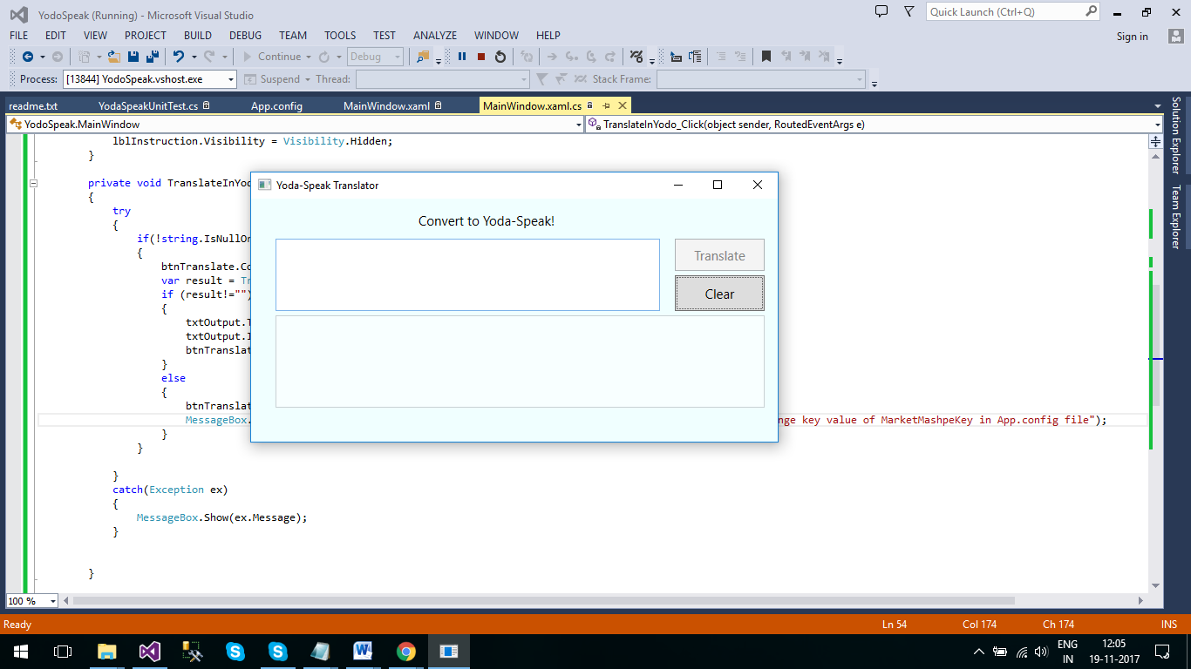

**Step 2:** After input your sentence in in top of textbox field click on “Translate” button and wait for a moment. Sometime it will take more time to give the result but don’t worry, result will be definitely appears after some moment.

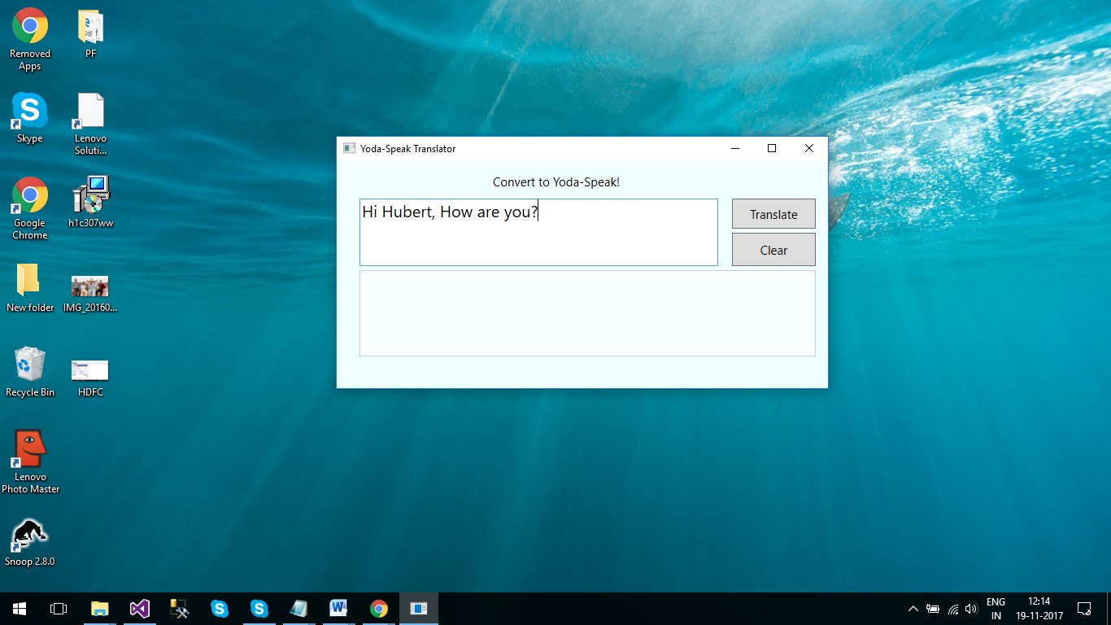

**Step 3:** After click on “Translate” button wait for some moment and you will see the result in bottom of the textbox as per below screen.

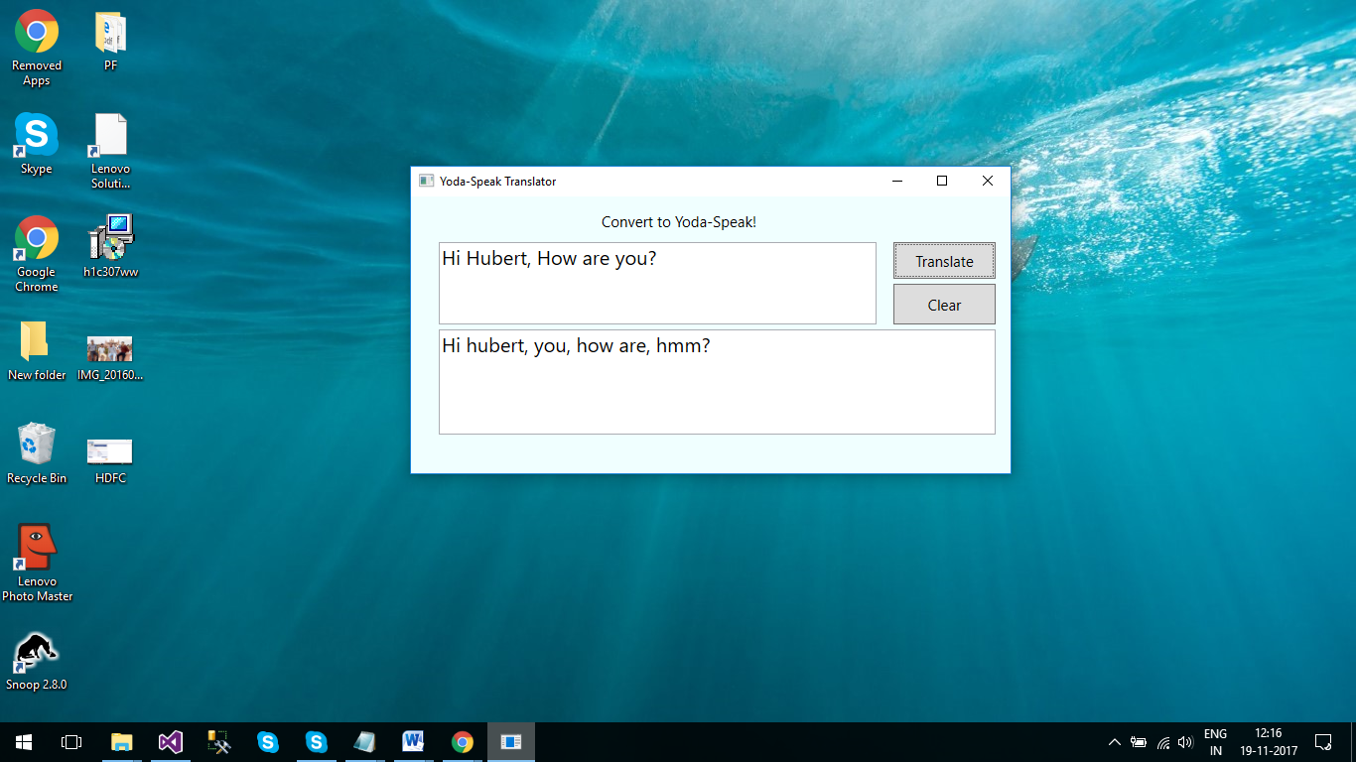

**Step 4:** We have added one more button(**Clear**) to reset the all field and after click on “Clear” button, application is again ready for Yoda-Speak translation.

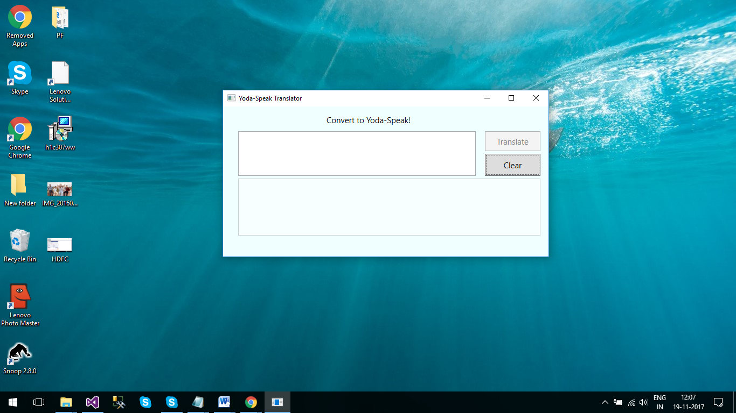

**Note**:- Sometime we need to replace the key value of **“**MarketMashpeKey**”**  in **App.config** file because we are using the Public(<https://market.mashape.com/ismaelc/yoda-speak>) API endpoint so, sometime it has limited access.

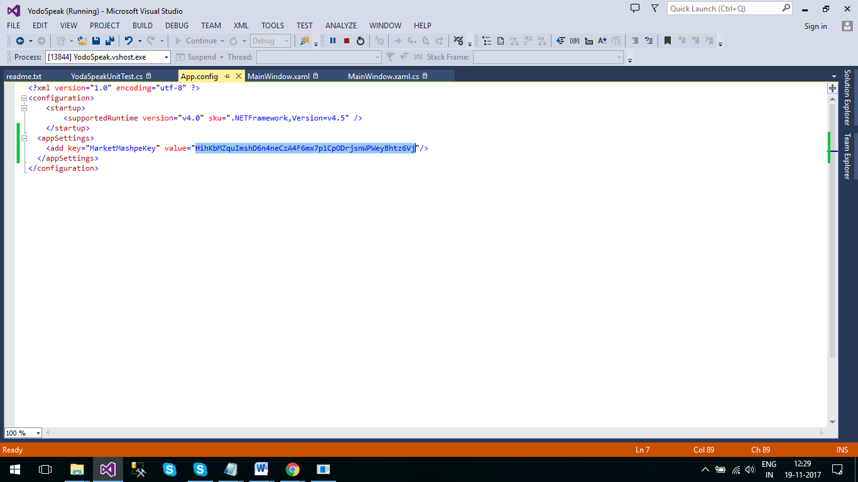

*** END ***